|  |
| --- |
| **School Leadership Academy, Nagaland** |
| **Case Study** |
| **Mentor-Mentee Programme** |

|  |
| --- |
| **Shri. M. Limasunep Imchen, Vice Principal** |



**Mentor-Mentee Programme**

**Key Area-3: Transforming Teaching Learning Process**

**About the Series**

*This Case Study presents the challenges faced by serving school leaders in Nagaland. The Case study is linked to one of the Key Area given in the Handbook for 30 Days School Leadership Development Programme developed by NCSL, NIEPA, New Delhi. The case study describes a problem faced by the School and the strategies used by the School Head to resolve it.*

**SCHOOL PROFILE**

**Name of School Head:** Shri. M. Limasunep Imchen, Vice Principal

**School Name:** N. I. Jamir GHSS, Ongpangkong Khensa

**Location:** Located in Khensa, 4.3 km from Mokokchung Town, Nagaland

**Phone Number:** 8119823120

**Email Id:** nijamirghss@gmail.com

Year of establishment: 1964

Total number of students: 189

Total Number of teachers: 28

Total number of classrooms: 8

Number of non-teaching staff: 9

**The Present Scenario of the School**

**Strengths:**

The school has good working environment with extremely committed and dedicated teachers. The principal is efficient and thoughtful. The school surrounding has fresh natural ambience with lots of available space for development.

**Weaknesses:**

The school has poor infrastructure like old school building which is at the verge of collapse as it was build in 1964, no water supply, no boundary wall and insufficient teachers.

**Opportunity:**

The very opportunity of making our school into a MODEL schools lies given the total area of the land which comes to around 8 acres which is in fact very rare in many other places. Till today, we have only arts stream. The opportunity of introducing science and commerce stream in higher secondary is always available.

**Threat Analysis:**

The school faces encroachment of school land due to non existence of boundary wall.

**The description of community-cultural pressures; values, needs and expectations; skills, chief occupation**

The impact of community and cultural influence on the school is very positive. The social values are very strongly embedded both among the students and teachers which act and serve as moral guardians for the school. With the exclusive help of the community, the school could establish a computer Lab with 15 computers. Young talents from the community are invited to help the school in many co-curricular activities. The social needs and expectations are many and varied. However, due to shortage of teachers and poor infrastructures, the school is unable to meet the expectations of the community

**PROBLEM: Students’ under Achievement and Parental Apathy.**

A Government High School has to admit students in class 9 from Government Middle Schools and in Class 6 from the Government Primary Schools in their area who are called feeder schools. The feeder schools are mostly located in nearby villages, where the population is involved in agriculture and most of the parents are illiterate. For this reason the school faces significant challenges in inducting students from its feeder schools who were academically challenged. Many of the students struggled with speaking and writing English due to a lack of practice while the medium of instruction in school and the official language in Nagaland is English.

The school head also realized that the parents and guardians showed little interest in the children’s education and their parental involvement in school was totally absent.

**The problem faced by the school head was ‘students’ under achievement and parental apathy.’**

The concept of mentoring came to light the while attending the sessions on Transforming Teaching Learning Process during the One Month Certificate course on SLDP conducted by SLA, Nagaland.

Mentoring is a reciprocal relationship that involves the transfer of knowledge and sharing of experiences between two individuals i.e. a mentor and a mentee. The mentor, typically more experienced, guides and supports the mentee, who seeks to grow professionally or personally. Mentors help develop the mentee's professional, personal and emotional skills. Mentors in a school can be teachers, parents, an advanced learner or a senior student. In education, mentoring entails partnering young people with an older peer or adult volunteer who serves as a positive role model.

Mentor-mentee relationship helps in building confidence, develops leadership skills, improve behavior both at home and at school. This in turn builds stronger relationships with parents, teachers and peers. Parental involvement in education helps teaching outside the classroom, creates a more positive experience for children and helps them perform better when they are in school.

**INTERVENTION**

Shri. M. Limasunep Imchen, Vice Principal decided it was essential to address the twin challenges of student under achievement and parental apathy. His solution was to set up a teacher led mentoring programme for the students who were poor in English.

He first created a framework for mentors based on the 3 C’s (Communication, Clarity and Commitment) keeping in mind the local scenario.

* Communication - Effective communication is a critical factor in establishing a productive and meaningful mentor-mentee relationship. The school head emphasized that both the mentor and the mentee should have clear understanding of each other's needs, goals, and aspirations.
* Clarity - Clarity is a crucial element when it comes to establishing a successful mentoring programme. By providing a clear direction, mentors and mentees worked together towards a common goal and ensuring that everyone is on the same page i.e. to improve their English speaking and writing.
* Commitment – The mentors and mentees were requested to be fully committed to the programme because the success of a mentoring program heavily depends on the level of commitment demonstrated by both the mentor and mentee.

In the frame work he paired students to teachers who were staying close to each other and also who spoke the same dialect. He also set the time intervals for meetings of the mentor and the mentee and the mode through which they can keep in touch.

After developing the framework for the Mentor-Mentee Programme, Shri. Limasunep shared it with the teachers. Since the Mentor-Mentee Programme was to improve English speaking and writing among the students, he requested all the English teachers in the school to be part of the programme but he also included young teachers from other subjects to act as mentors. The school head and the teachers together identified the weak students and 10 teachers and 20 students were assigned to the programme

During the programme, the mentors evaluate the academic progress of their mentees, identified learning difficulties and coordinate with other mentors to provide their mentees with remedial help. They also address emotional, social, and personal problems and made home visits to strengthen the bond between the school and their parents. Mentors kept in constant touch with their mentees and parents through telephonic conversations and home visitation and submitting monthly report cards.



**THE OUTCOMES**

1. **Personalized Guidance:** Students received personalized attention and support from their mentors. Knowing they had someone to turn to for academic and personal advice, students became more invested in their learning journey.
2. **Vibrant Culture:** The positive outcome of the programme has been the growth in the improved relationships between teachers, students, and parents. Mentees felt comfortable seeking help from their mentors and parents become more involved in their children's education.
3. **Improved Student Outcomes:** Mentees reported higher academic achievement due to the personalized guidance and mentor support. One of the most significant outcomes observed in the school was the consistent improvement in student academic performance and personality development.

The overall performance of the school also improved which is shown in the table.

|  |  |  |
| --- | --- | --- |
| **Year** | **Pass Percentage of HSLC** | **Pass Percentage of HSSLC** |
| 2022 | 39% | **95%** |
| 2023 | 88.48% | **92%** |

**Impact beyond the School**

The news of the success of the programme has spread beyond the school. Jubilee Memorial Higher Secondary School, (Affiliated with CISCE) reached out to Shri. Limasunep and has launched its own Mentor-Mentee Programme. Senayangba GHSS, Mokokchung and GHSS Wokha have also implemented the Mentor-Mentee Programmes during this academic year.

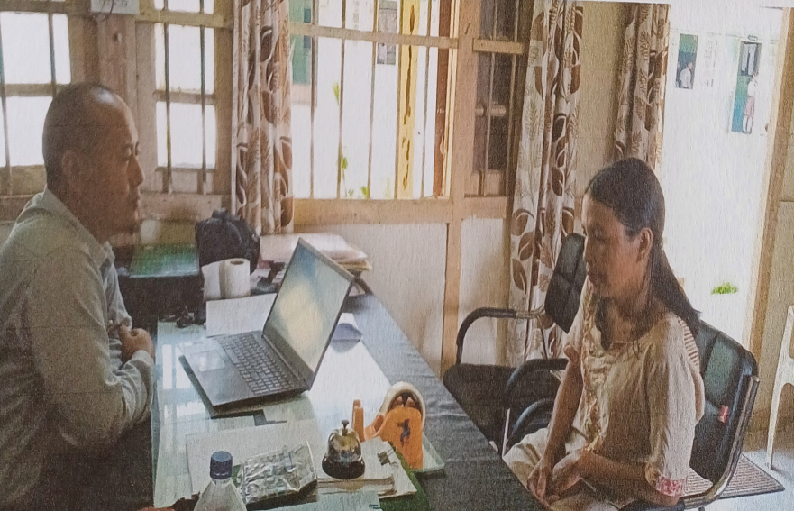

**CONCLUSION**

Mentoring programs in schools play a role in knowledge transfer, career advancement and fostering human connections. This two-way exchange of feedback and ideas positively impacts individuals and organizations by increasing retention, advancement, professional growth and builds healthy relationships. The benefits of Mentor-Mentee programme at N.I.Jamir GHSS, Khensa not only benefited the students in improving in speaking and writing English language but also developed a sense of responsibility among the teachers and parents.

For any programme to be successful, commitment, sincerity and accountability is very important. Shri. M. Limasunep Imchen, Vice Principal of N.I.Jamir GHSS, Khensa showed exemplary leadership skill by introducing Mentor-Mentee Programme for improving English language in their school. The result was very impressive and thus, he could influence other schools to introduce the programme in their schools. He is a School Leaders who is striving to make the school even better.

**Reflective Questions:**

1. What resources or support will you need to introduce the Mentor-Mentee programme in your school, considering its positive outcomes?
2. How will you plan to continuously monitor and evaluate the effectiveness of the mentor-mentee model and adjust it to adjust it to match your context?
3. What strategies do you believe need to be put in place to ensure the long-term success and growth of this initiative? Would it be possible to involve the local community as mentors and not only teachers?
4. **A Celebration:** How has the school leader’s mentor-mentee programme positively fostered a supportive and collaborative environment through the Mentor-Mentee programme? And what was it that contributed to the improved exam performance of the students? What would be the appropriate ways in which the school can appreciate and celebrate these efforts?